GreenPod Labs
Data Science Assignment Report
Report on Orange Classification:
1. Problem Statement: This project focuses on developing a computer vision pipeline for detecting and classifying orange fruit defects using image analysis and machine learning techniques. The dataset consists of healthy oranges and defective oranges affected by diseases such as Blackspot, Canker, and Grenning.
Introduction: The objective of this project is to develop a computer vision pipeline capable of detecting and classifying orange fruit defects into multiple categories. The dataset consists of healthy oranges and defective oranges exhibiting diseases such as blackspot, canker, and grenning.
Two different approaches were implemented and compared:
- Classical Computer Vision combined with Machine Learning using HSV histogram features, Local Binary Pattern (LBP) texture descriptors, and Random Forest classification.
- Deep Learning using MobileNetV2 transfer learning architecture.

The system aims to classify orange defect types accurately while also estimating spoilage percentage for defective fruits.
2.Dataset understanding: There are a total of 1090 images in which train images are 991 and test images are 99, in these there are four classes (Fresh,Blackspot,Canker,Grenning).
Class | Description
Fresh | Healthy oranges
Blackspot | Oranges affected by blackspot disease
Canker | Oranges affected by canker disease
Grenning | Oranges affected by grenning disease

s.no | class | count | Percentage%
0 | train/blackspot | 184 | 16.880734
1 | train/canker | 179 | 16.422018
2 | train/fresh | 281 | 25.779817
3 | train/grenning | 347 | 31.834862
4 | test/blackspot | 22 | 2.018349
5 | test/canker | 22 | 2.018349
6 | test/fresh | 33 | 3.027523
7 | test/grenning | 22 | 2.018349

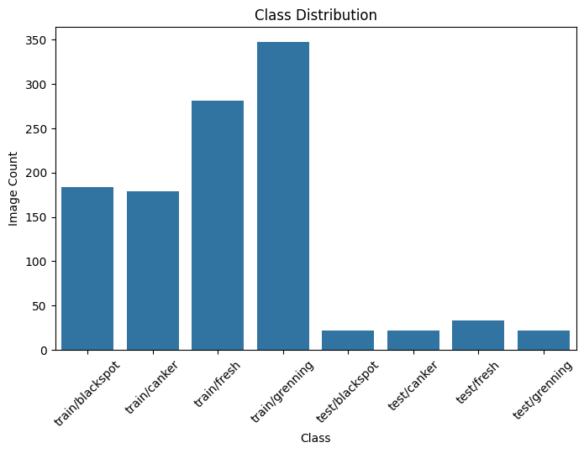
Fig: class distribution

Image Dimension Analysis
 | Width | Height
count | 1090.000000 | 1090.000000
mean | 669.022018 | 659.438532
std | 211.551046 | 224.984294
min | 144.000000 | 138.000000
25% | 454.500000 | 400.000000
50% | 800.000000 | 800.000000
75% | 800.000000 | 800.000000
max | 800.000000 | 800.000000

The dataset exhibits moderate class imbalance. The grenning category contains the highest number of images, while canker contains the lowest.
Image dimensions vary considerably, with most images standardized at 800×800 pixels but some smaller images acting as outliers.
No corrupted images were identified during integrity verification.

3.Exploratory Data Analysis
Exploratory Data Analysis (EDA) was performed to understand dataset characteristics before model development. The analysis focused on class distribution, image dimensions, dataset quality verification, and visual inspection of disease categories.
Class Distribution Visualization
The dataset exhibits moderate imbalance, with Grenning containing the largest number of samples and Canker containing the fewest.
Potential issues associated with class imbalance include:
- Bias toward majority classes
- Reduced minority class detection performance
- Uneven model generalization
To reduce these effects:
- Data augmentation was applied
- F1-score was considered alongside accuracy
Image Dimension Analysis
Image dimensions varied across the dataset.
Findings:
- Most images were standardized to 800×800 pixels
- Small dimensional outliers were observed
- Image resizing was required before training
Dataset Quality Verification
Corrupted image detection confirmed dataset integrity.0 corrupted images.
Images with smaller dimensions (minimum width 144 and minimum height 138)
were treated as dimensional outliers and standardized during preprocessing.
Visual Inspection
Visual examination revealed disease-specific characteristics:
Blackspot:
- Dark localized patches
- Irregular texture variation
Canker:
- Rough infected regions
- Larger damaged surface areas
Grenning:
- Green discoloration patterns
- Significant color distribution changes
Fresh:
- Uniform orange coloration
- Minimal texture abnormalities
4.Data Preprocessing
Image Resized to 244 x 244
Reason: To ensure consistent feature extraction and reduce computational complexity.
Feature Extraction (Approach 1)
Two handcrafted feature extraction methods were implemented.
HSV Histogram Features
HSV color representation was used because disease conditions often introduce color changes.
HSV features capture:
- Hue variation
- Saturation distribution
- Brightness characteristics
These features help identify discoloration defects such as Grenning.
Local Binary Pattern (LBP)
LBP texture descriptors were used to capture surface irregularities.
LBP identifies:
- Texture patterns
- Disease surface variations
- Local intensity relationships
This was particularly useful for Blackspot and Canker detection.
Feature Concatenation
HSV histogram features and LBP texture descriptors were combined into a unified feature representation.
5.Approach 1: Classical Computer Vision with Random Forest
The first approach combined handcrafted image features with a machine learning classifier.
Architecture:
Input Image
↓
Resize
↓
HSV Histogram Extraction
↓
LBP Texture Extraction
↓
Feature Combination
↓
Random Forest
↓
Orange Defect Classification
Random Forest was selected because:
- Handles tabular feature vectors effectively
- Robust against overfitting
- Computationally efficient
- Performs well on moderate-sized datasets
Given the dataset size (1090 images), Random Forest provides strong generalization without requiring extensive computational resources.
5.1 Training Configuration for Random Forest
Random Forest Parameters:
Number of Trees (n_estimators): 100
Random State: 42
Feature Representation:
HSV Histogram + LBP Features
5.2 Evaluation Metrics:
Metrics used:
Accuracy: Measures overall prediction correctness.
Precision: Measures false positive control.
Recall: Measures defect detection capability.
F1-score: Balances precision and recall, particularly useful for moderately imbalanced datasets.
Confusion Matrix: Provides class-level error analysis.
5.3 Model 1: Result
Accuracy: 0.9597989949748744
precision recall f1-score support

blackspot 0.84 0.97 0.90 37
canker 0.97 0.81 0.88 36
fresh 1.00 1.00 1.00 56
grenning 1.00 1.00 1.00 70

accuracy 0.96 199
macro avg 0.95 0.94 0.94 199
weighted avg 0.96 0.96 0.96 199
5.4 Confusion Matrix Analysis
The confusion matrix revealed strong classification capability across most disease categories.
Observations:
- Fresh oranges achieved perfect classification.
- Grenning oranges achieved perfect classification.
- Blackspot and Canker occasionally exhibited confusion.
The visual similarity between Blackspot and Canker likely contributed to misclassification.
Interpretation
The handcrafted HSV and LBP feature representation effectively captured disease characteristics, particularly color variation and texture abnormalities.
The Random Forest model demonstrated strong generalization despite moderate dataset imbalance.
6 Approach 2: MobileNetV2 Deep Learning
The second approach utilized MobileNetV2 transfer learning architecture to automatically learn image representations.
Architecture:
Input Image
↓
Resize (224×224)
↓
Normalization
↓
MobileNetV2 Feature Extraction
↓
Global Average Pooling
↓
Dense Layer
↓
Softmax Classification
MobileNetV2 was selected because:
- Lightweight architecture
- Reduced computational complexity
- Strong transfer learning capability
- Effective performance on moderate image datasets
Transfer learning allows pretrained ImageNet features to accelerate convergence and improve feature representation quality.
6.1 Training configuration:
Training Configuration:
Epochs: 15
Batch Size: 32
Optimizer: Adam
Loss Function:
Categorical Crossentropy
Callbacks:
EarlyStopping
ReduceLROnPlateau
Transfer Learning:
ImageNet Pretrained Weights

6.2 MobileNetV2 Results
Best Validation Accuracy:
98.47%
Final Test Accuracy:
93.94%
Classification Report:
Class | Precision | Recall | F1-score
Blackspot | 0.87 | 0.91 | 0.89
Canker | 0.86 | 0.86 | 0.86
Fresh | 1.00 | 0.97 | 0.98
Grenning | 1.00 | 1.00 | 1.00
Weighted F1-score:
0.94
Macro Average F1-score:
0.93
6.3 Confusion Matrix Analysis
Observations:
- Grenning achieved perfect classification.
- Fresh oranges exhibited near-perfect classification.
- Blackspot and Canker remained the most challenging categories.
Interpretation
Although MobileNetV2 achieved very strong validation performance, final test accuracy remained slightly lower than the Random Forest approach.
This demonstrates that higher validation accuracy does not always guarantee stronger generalization performance.

7. Model Comparison
Metric | Random Forest | MobileNetV2
Approach Type | Classical CV | Deep Learning
Accuracy | 95.98% | 93.94%
Feature Engineering | Manual | Automatic
Computational Cost | Low | Moderate
Training Complexity | Low | Higher
Generalization | Strong | Moderate

Comparative Analysis
The Random Forest approach achieved slightly higher final performance despite using handcrafted features.
Possible reasons:
- Moderate dataset size favored classical methods.
- HSV and LBP features effectively captured disease characteristics.
- Deep learning models typically benefit from larger datasets.
For this dataset, the Random Forest model was selected as the preferred approach.

Although MobileNetV2 achieved stronger validation performance,
Random Forest demonstrated better unseen test performance
(95.9% vs 93.9%) and lower computational complexity.
Therefore, Random Forest was selected as the preferred model
for this dataset.

8.Spoilage Percentage Estimation
In addition to defect classification, spoilage quantification was performed to estimate the severity of fruit damage. This module measures the proportion of damaged fruit area relative to the total fruit area.
Objective
The spoilage estimation system was designed to:
- Measure defect severity
- Quantify damaged fruit area
- Provide additional information beyond defect classification
Methodology
The spoilage estimation pipeline was implemented using image segmentation techniques.
Input Image
↓
HSV Color Space Conversion
↓
Fruit Segmentation
↓
Defect Segmentation
↓
Pixel Counting
↓
Spoilage Percentage Calculation
Fruit segmentation isolates the orange region, while defect segmentation identifies damaged areas within the fruit.
Spoilage percentage formula:
$$Spoilage Percentage=\frac{Defect Pixels}{Fruit Pixels}×100$$
Spoilage Results: One image was selected from each spoilage category.
Disease Type | Spoilage Percentage
Blackspot | 9.47%
Canker | 72.33%
Grenning | 3.28%

9.Example Run Demonstration
An end-to-end system demonstration was performed using a sample orange image.
System pipeline:
Input Orange Image
↓
Feature Extraction
(HSV + LBP)
↓
Random Forest Classification
↓
Defect Prediction
↓
Spoilage Estimation
↓
Final Output
Example output:
Input Image:
Orange Fruit Sample
Predicted Defect:
Blackspot
Spoilage Percentage:
9.47%
The system successfully classified the defect type and estimated damage severity simultaneously.
This demonstrates the practical applicability of the proposed computer vision pipeline.

10.Conclusion
This project developed a computer vision pipeline for automated orange defect detection and spoilage estimation.
Two approaches were implemented and compared:
- Classical Computer Vision using HSV histogram features, Local Binary Pattern texture descriptors, and Random Forest classification.
- Deep Learning using MobileNetV2 transfer learning architecture.
Experimental evaluation demonstrated that both approaches achieved strong performance.
Random Forest achieved:
95.98% Accuracy
MobileNetV2 achieved:
93.94% Test Accuracy
The Random Forest approach produced slightly stronger final performance for this dataset, likely due to the moderate dataset size and effectiveness of handcrafted feature representations.
Additionally, spoilage estimation provided quantitative assessment of defect severity, improving system interpretability.
The developed pipeline demonstrates the feasibility of combining image processing and machine learning techniques for automated fruit quality assessment
11. Future Improvements
Potential improvements include:
- Larger dataset collection
- Additional defect categories
- Improved segmentation methods
- Fine-tuning deeper neural network architectures
- Real-time deployment capability
- Object detection approaches for precise defect localization
Future work may also explore advanced architectures such as EfficientNet and Vision Transformers for improved defect recognition performance

Q & A:
In production how your model performs?
In the current project, the Random Forest model achieved 95.98% accuracy, while MobileNetV2 achieved 93.94% test accuracy. Based on unseen test data performance, the Random Forest model generalized slightly better for this dataset.
In production, performance may reduce compared to controlled test environments because of variations such as lighting conditions, camera quality, fruit orientation, background differences, and unseen defect patterns.
To improve production robustness, additional diverse data collection and continuous model monitoring would be required.
What is the drawback of your model?
The primary drawback is limited dataset diversity. The dataset contains 1090 images, which may not fully represent real-world production conditions.
Another limitation observed was confusion between Blackspot and Canker, indicating visual similarity between certain defect classes.
The spoilage percentage estimation uses threshold-based segmentation, which may become sensitive to lighting variations.
Additionally, the current pipeline performs image-level classification and does not precisely localize defect regions.
If given more time, what would you improve?
If given additional time, I would improve the project in several ways:
- Collect a larger and more diverse dataset.
- Improve spoilage estimation using segmentation-based deep learning methods such as U-Net.
- Fine-tune MobileNetV2 further or experiment with EfficientNet architectures.
- Implement defect localization using object detection techniques.
- Deploy the model through a web application or real-time inference pipeline.
- Perform hyperparameter optimization to further improve generalization performance.

Where did you spend more time during solving your assignment?
I spent the most time on preprocessing, feature engineering, and model comparison.
Designing the Classical Computer Vision pipeline required experimentation with HSV histogram features, Local Binary Pattern texture descriptors, and evaluating how these features captured disease characteristics.
I also spent significant time setting up the deep learning environment because TensorFlow compatibility issues required creating a dedicated Python virtual environment.
Another important area was validating spoilage estimation logic and comparing Random Forest against MobileNetV2 to ensure proper model selection.
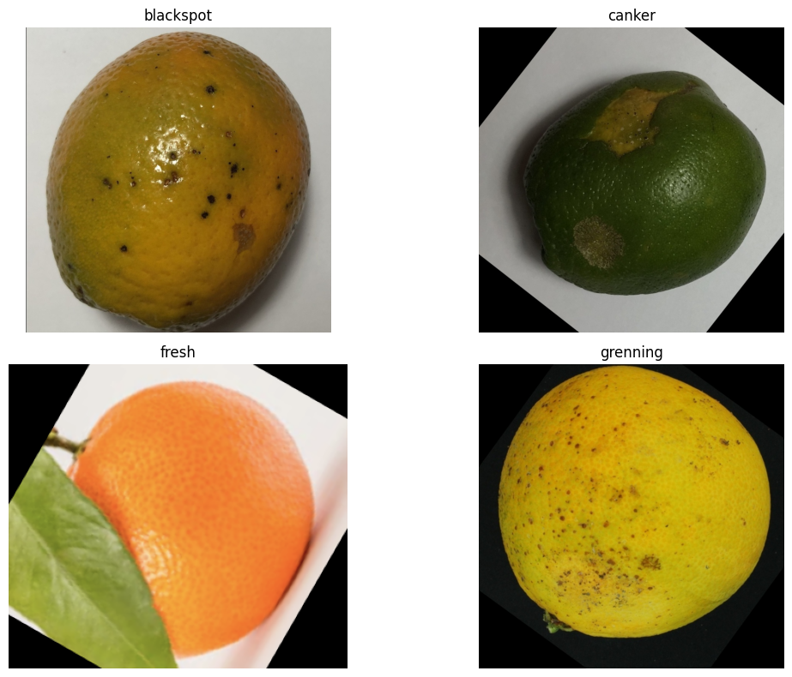
Fig: Images from the dataset
References:
1. TensorFlow Documentation:
https://www.tensorflow.org/
2.OpenCV Documentation:
https://opencv.org/
3.Scikit-Learn Documentation:
https://scikit-learn.org/
4.MobileNetV2 Paper:
MobileNetV2: Inverted Residuals and Linear Bottlenecks
5.Dataset Source:
Provided assignment dataset

